Example
Implementation
Plan
This example plan has been created to support your firm
in meeting the regulator’s expectations and framework.

Introduction
This document has been created to assist your practice in demonstrating the work undertaken to meet the latest Consumer Duty criteria. Full implementation of the Consumer Duty framework needs to be in place by 31 July 2023.
Please ensure you have discussed the FCA’s expectations with all staff.
This document is the commencement of Consumer Duty and will simply outline the steps your firm plans to implement.
The FCA required firms to have an initial implementation plan by 31 October 2022, but it is good practice to develop this plan and integrate it into business-as-usual planning. Ongoing planning on compliance with the Consumer Duty will include evidence of the work your firm has done, and intends to undertake in future, to meet the Consumer Duty outcomes as different issues evolve – for example, sustainable and values-based (including ESG).
The plan:
This document is broken down into two parts for you to complete;
Part 1 The Implementation Plan
Part 2 The Project Plan
The Implementation Plan provides an overall summary of the FCA’s objectives, who will be responsible and what action will be taken to meet the objective.
The Project Plan will drill down and review the specific actions required by your firm and set realistic timescales for completion.
It is important that you fully document your journey so this can be evidenced to the FCA. We would encourage you to use the Consumer Duty Interim & Ongoing Review document to record your progression (See the example Project Plan below).
Implementation Plan
The main objective of this plan is:
- To provide a documented journey for your firm to satisfy the requirements of the Consumer Duty
- To enable the execution and formalising of the framework
- To ensure you meet the Consumer Duty deadlines
Please outline the key staff who will be responsible in implementing the Consumer Duty.
Staff Name | Position in Business | What Responsibility
 | Senior Manager | Head of Project

We would recommend that you spend time completing the Consumer Duty Gap Analysis. This will outline any shortfalls in your business and ensure you are meeting the four Consumer Duty outcomes. The component parts of Consumer Duty are outlined below.
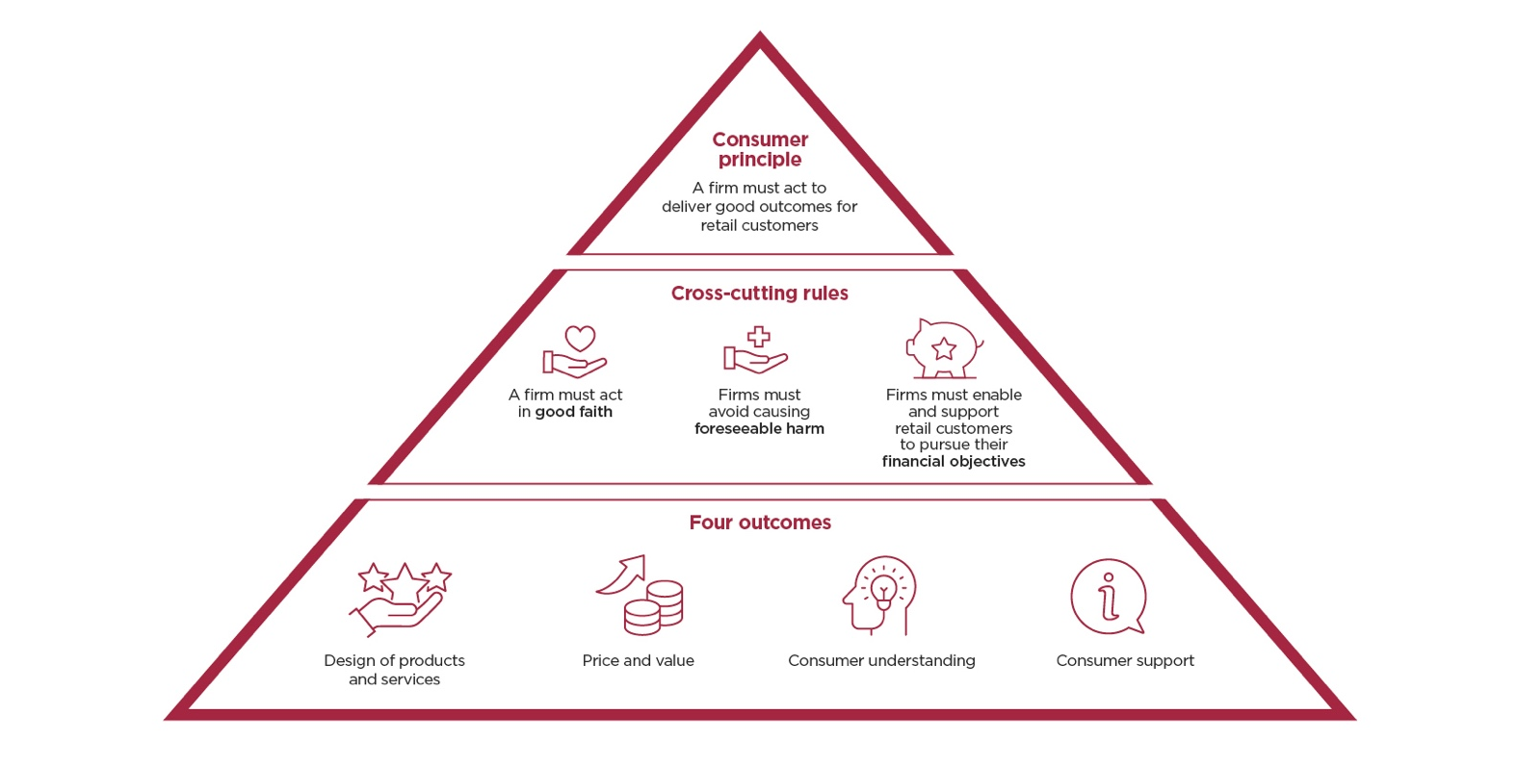
It is important that you then prioritise and action any shortfalls. This process should be fully documented to demonstrate the firm’s progression and involve all staff.
It may be appropriate for you to create groups to manage the delivery and to also outline who is responsible for each group. Obviously, any groups would be dependent on the size of your practice.
Please find below examples of groups that could be created:
- Products and Service group
- Price and Value group
- Consumer Understanding group
- Consumer Support group
Once you have established your actions, it is recommended that you undertake regular group meetings to develop any areas and ensure suitable procedures are in place. This could take multiple meetings however it will provide useful demonstration to the FCA on the work you have completed. This can be achieved by completing the Interim & Ongoing Review document.
We have established the following groups and will complete work in each area to ensure that we are meeting the FCA standards.
Group | Group Leader
Products and Service group | Insert name
Price and Value group | Insert name
Consumer Understanding | Insert name
Consumer Support | Insert name

Project Plan
This section will now cover part 2 of the implementation, and this section is designed to document your journey and progression. This will help demonstrate how you are addressing any gaps or shortfalls to ensure you are meeting the FCA’s expectations of Consumer Duty.
The below document should be used to demonstrate the ongoing project work conducted by your firm. This will cover the actions taken since your original gap analysis.
Consumer Duty Interim Review
We have conducted an interim review of our Consumer Duty project work to ensure we are progressing in a positive manner.
The following summarises the gaps that we identified as part of our initial Consumer Duty Implementation Assessment.
Please note the below are examples and should be fully tailored to meet your needs and objectives.
The Action Plan
Area Identified | Actions To Be Taken | Senior Manager Responsible | Implementation Plan Group | Date Completed
Introducers | Undertake a full overhaul of each introducer and ensure appropriate due diligence is up to date and agreement is in place and accurate. Discuss with the team to ensure thorough understanding and firm expectations. |  | Products & Services
Fair Value Assessment | Complete this assessment and ensure our charges are fully reviewed and considered. Discuss as a team to ensure understanding and consistency within the firm. |  | Products & Services
PROD & CIP | We need to include this as part of our CIP criteria. We will earmark future compliance meetings to review this area. |  | Products & Services
Non-engaging Clients | We need to create a formal process that would be adopted for non-engaging clients and ensure all staff have a thorough understanding. |  | Consumer Support
Social Media | We need to reiterate our company standards and ensure advisers are aware of the risks and not commenting and making any recommendations or opinions. |  | Consumer Understanding
Disclosure Documents | Undertake a full overhaul of our initial and ongoing service documents. Ask a friend/relative to review the document to ensure information is clear and not misleading. |  | Consumer Understanding
Sustainable and values-based (including ESG) | We need to ensure that advisers fully under the sustainable and values-based (including ESG) criteria and discuss further information with clients to ascertain their needs and objectives. Ensure this is being recorded appropriate in the fact find. |  | Products & Services
Surveys | Contact our PI insurer to ensure they are comfortable with our surveys. We are considering using Vouched For to meet this goal. |  | Consumer Support & Understanding
KPIs | We need to undertake KPI assessments on a six-monthly basis on each adviser. We will engage with our Compliance Consultant for guidance. |  | All

Overview and Development
Please find below an overview to our progression in each area. This review was conducted to demonstrate our progression in meeting the FCA four Consumer Outcomes.
Introducers
We are still progressing through our Introducer Due Diligence and will have re-visited each party. We will ensure all due diligence is formalised. We will also discuss our Introducer requirements with all relevant advisers to ensure they are aware of the risks of appointing future introducers. Introducers need to be aware that they simply introduce the client, and we are the advisers to the client. We will ensure we undertake all engagement and to clearly outline the needs and objectives of the client directly. We have utilised our Compliance Consultants Introducer guidance in this area for assistance.
Fair Value Assessment/Charging Structure
This is a key area for our business, and we are currently discussing our fee structure. This review will require a full overhaul of our initial and ongoing advice charges. We have completed this assessment; however this now needs formal sign-off by the board.
PROD
We have now incorporated PROD as part of our CIP. Our Compliance Consultant has now provided us with PROD criteria that we will include as part of this assessment. We are fully aware of the FCA standards and know our responsibilities as the distributor or retail investment products.
Non-Engaging Clients
We have now created a formal process which outlines the steps we would undertake with any clients that do not actively engage with us. This is very few and far between, however we thought a formal process would be beneficial to ensure there is a thorough understanding within our firm. We will now share this document at our upcoming team meeting for full understanding.
Social Media
We discussed this area with our Compliance Consultant at a recent meeting and we need to ensure that we actively monitor our adviser’s social media accounts. We will reiterate our company standards at our upcoming team meeting to ensure they are aware of the risks of commenting/opinions on certain areas. It is important that any mortgage marketing has clear caveats about subject to availability, underwriting and confirmation that rate deals can be removed from the market at any time. If advisers use the phrase ‘Independent’ in their mortgage branding then they must issue you the relevant property risk warnings along with any typical fees we may charge. This is an area that no doubt will continue to evolve and we therefore need to ensure that we monitor adverts and continue to remind advisers of their responsibility.
Disclosure Documents
We still need to undertake a full overhaul our disclosure documents. We will liaise with our compliance consultant for assistance and discuss the document as a group. We will provide our documents to a friend/relative that has no financial services experience to review the documents to ensure they understand the content. We will ask them to be honest with feedback and we will consider any suggestions. We are also running through a rebrand, so this is perfect timing for a full review. We will earmark the end of May 2023 for completion.
Sustainable and values-based (including ESG)
We need to ensure that advisers fully understand the sustainable and values-based (including ESG) criteria and discuss further information with clients to ascertain their needs and objectives. Ensure this is being recorded appropriate in the fact find and advisers are using open questions.
Surveys
We have recently changed our PI insurer so we will request if they have any pre-approved surveys that we could distribute to clients. We will then decide the frequency and whether we wish to pursue this activity. If we did, then we need a process for reviewing all feedback and ensure these are stored and discussed with advisers as part of their KPI/121 meeting.
KPIs
We need to undertake KPI assessments on a six-monthly basis on each adviser. We will engage with our Compliance Consultant for guidance. We need to diarise our first batch of KPI meetings and know that each meeting will generate better MI in the future.
Annual Review Process
We have completed the Fair Value Assessment document from our compliance consultant. We will work through this document which will outline any gaps or action that is needed. We are aware that ongoing reviews are as important as new business. We operate a diary system which prompts us when to initiate contact with clients. At review meetings, we fully update the client’s needs/objectives, ATR, capacity for loss, investment performance, market outlook and discuss any future aims/goals. This process is fully documented, and we always provide clients with a formal outcome. We have agreed that our Compliance Consultant will undertake assessments on our review process to ensure it would meet the FCA’s standards.
Income and Expenditure Assessment
Advisers always discuss affordability with clients and would discuss the current living cost crisis when clients are making regular and lump sum contributions. Advisers would always ensure appropriate emergency funds are in place.

Summary
We feel this has been an effective review of Consumer Duty work and we are moving in a positive manner. We are gradually implementing and rectifying the gaps identified as part of the initial assessment.
Due to the size and structure of the business, we feel we are in a good position to meet the FCA’s standards. All clients are retail clients, and we feel we deliver a professional and personable service. We will re-visit our action plan at our next meeting on [insert date]. to ensure we continue to progress.
Interim Review completed by [insert name], Managing Director and [insert name],, Director on [insert date].

The Project Plan contains the following areas;
(Please tailor these to meet your business model)
Project setup | Setting out the foundations of the project, identifying key staff, setting up the groups/teams, allocating ownership/responsibility to each senior manager, timescales for delivery etc.
Research | Complete the gap analysis, which will identify areas that need further attention and resources. This will also generate documentation so you can demonstrate how you are meeting the FCA’s standards.
Groups | Create relevant groups to undertake project work on each area of the duty. Please refer to the previous group for a full breakdown.
Approval | This will ensure your senior managers are approving all key decisions as you navigate through this project.
Testing | This will require you to stress test the changes to ensure they are effective, robust and working for your business.

